**CMSC 180: Introduction to Parallel Computing**

**Second Semester 2022-2023**

**Interpolating the elevations into a higher resolution digital elevation matrix M given a lower resolution digital elevation matrix N**

*Ariel Doria*

**Introduction**

Before dealing with the design, implementation, and performance evaluation of parallel algorithms and software, you will refresh your knowledge of algorithm implementation and analysis.

**Contents**

1. Introduction
2. Contents
3. Learning Objectives
4. Discussion
5. References

**Learning Objectives**

At the end of this discussion, the student must be able to:

* Understand how the interpolating elevation could be solved using serial programming; and
* Explore the methods in solving interpolating elevation

**Discussion**

The topographic elevation database includes elevation values on a grid of latitude and longitude (seen in Figure 1) (*Terrain Elevation Interpolation*, 1999). It forms a $m x n$ matrix M with $m$ rows and $n$ columns.

For some instances, a lower resolution digital matrix does not provide all grid points’ elevation. To make it a higher-resolution digital matrix, a method needs to be applied to fill in the elevation of other points such as interpolation (see Figure 2).

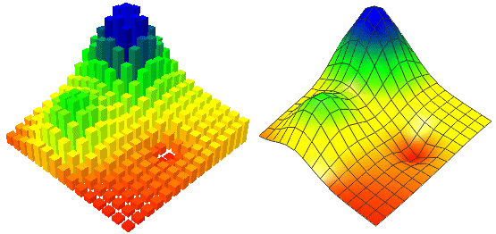

*Figure 01. Set of Independent Discrete Elevation Samples and as a Constrained Topological Grid of Elevations With an Implicit Linear Surface Over the Grid "Cells"* (Kidner et al., 1999, #)

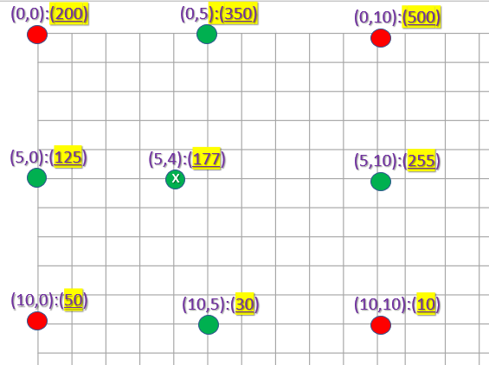

*Figure 2. Matrix visualization of topographic elevation. Red points are given values while greens are the interpolated values*

***Methods for Interpolating Values***

1. **Federal Communications Commission (FCC) Interpolation**

Given data points (A, B, C, D) around the intermediate points G, interpolate linearly on lines AB and CD to determine the elevation at points E and F, respectively, Then interpolate linearly on line EF to determine the elevation at the intermediate point G.

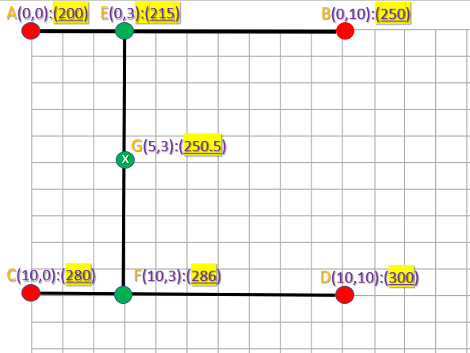

You may use this formula to interpolate f(x) given (x1,y1), (x2,y2) and x:

$y = y1 + (\frac{(x - x1)}{(x2-x1)}) * (y2-y1)$

1. **Area Weighted Interpolation**

Given data points (A, B, C, D) around the intermediate point E, get the area that surrounds the intermediate point E. Then use the computed area as your *weight* multiplied by the elevation of the given point.

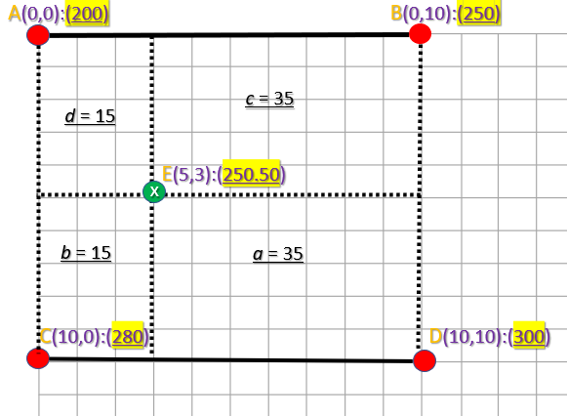

The formula for solving the elevation of point E will be:

$E = \frac{aA + bB + cC + dD}{a+b+c+d}$

By substituting the values:

$E = \frac{35(200) + 15(250) + 35(280) + 15(300)}{35+15+35+15} =250.5$

There are other ways how to interpolate the value. You can refer to other references.

**References**

Kidner, D., Dorey, M., & Smith, D. (1999). What's the point? Interpolation and extrapolation with a regular grid DEM. In *Proceedings of the 4th International Conference on Geocomputation: Mary Washington College : Fredericksburg, Virginia : 25-28 July, 1999* (-). GeoComputation CD-ROM. http://www.geocomputation.org/1999/082/gc_082.htm

*Terrain Elevation Interpolation*. (1999). SoftWright. Retrieved January 19, 2023, from https://www.softwright.com/faq/support/Terrain%20Elevation%20Interpolation.html